ASHCROFT SURGERY

2011/2012

PATIENT PARTICIPATION DES

SURVEY

REPORT

Chris Rushton
Manager
March 2012

Intro:

The practice agreed to implement the national patient participation directly enhanced service (DES) as we believe that patient views and comments can highlight issues for change so an improved or less frustrating service to patients.

The practice previously operated face to face meetings with its patient group up until 2009, meeting, open to all but resulting in meeting the same 12 patients every time. This group did help with the move to new premises, but then felt its main purpose had ceased.

The practice being a member of the Health On the Streets (HOT’s) project, restarted as a shared patient group, with patient reps from each of the 5 practices. Initially we intended to use this group for the 2011/12 DES, but we felt the rules didn’t allow it.

Therefore, we opted to implement a virtual patient group, using email, in the hope that the practice would get an increased number of patients willing to contribute and flexible on the times when people could contribute. This worked and we doubled our patient numbers. We did try to encourage all registered patients to be part of the group with slips attached to prescriptions, waiting room posters, staff briefed to discuss with patients, slips at reception and at the local chemist.

Returned slips generated a welcome email from the manager with the patient email address being added to a group contact email list. This virtual group email contact list was then used to assess the PCT ‘core’ questions of the template survey and add any local ones, thereby develop the practice patient questionnaire.

Profile of the patient group:

All registered patients could be members of the practice patient group. Any that indicated didn’t have email were then included via post. From those patients that completed the slips, their:-

Age range - < 30 = 4.1%
- 30-40 = 8.4%
- 40-50 = 16.7%
- 50-60 = 33.4%
- 60-70 = 16.7%
- 70-80 = 12.5%
- 80-90 = 4.1%
- 90-100 = 4.1%

Ethnicity - 16.7% were not from white English.

This is about in line with our practice profile, last completed in 2010 by the PCT on the practice behalf, and attached as an appendix to this report.

Practice steps taken to match representation with registered patients profile:

The practice felt that for the 2 months the slips were attached to prescriptions, at reception, at the chemist, supported by waiting room posters, we would capture a % of all those registered patients that were attending the surgery and/or being issued with prescriptions.

This was supported by HOT’s (Health On The Streets) as one of the 5 practices whom are members and sit on its quarterly steering group. HOT’s raised the practice survey with its groups, usually being difficult to interact with groups. District nurses case manager, midwives and Health Visitors were also aware to raise it with their clients.

From the age range and ethnicity results, it does appear to show a trend match with our practice population.

Steps to reach agreement with the patient group on priority issues:

With our alliance, a core questions survey was developed that had input from a range of areas including the PCT patient groups, which have included practice patients. This core survey therefore already covered a wide range of issues that affect practice patients.

From past practice patient comments, the practice had just amended the appointment process so suggested to the new email patient group adding two local questions about this. This made 18 questions in total, which was felt sufficient. So the draft survey was circulated to this patient group for there comments, amendment and final agreement. Replies made suggestions, and agreement, with a manager thank you email for their effort. Once the survey was agreed, the practice with the PCT assistance offered it electronically via survey monkey or in paper form at the surgery.

Encourage use of the Survey

To obtain our patients views, we now had to publicize the agreed survey, which was done in a number of ways:-

- Posters in practice
- E-mail to patient group confirming its gone live
- Slips attached to prescriptions
- Slips to pharmacies to attach
- Practice staff briefed a number of times to raise with attending patients.
- Raised at a number of GP meeting.
- Survey to run for two months, thereby coving a number of registered patients attending the surgery and/or collecting prescriptions.

Discuss the results and action plan

Once the survey was completed, its results were discussed at a practice meeting on the 13th February 2012. This meeting developed suggested areas so a draft action plan that was then e-mailed to patient group for their consideration, input, comments and agreement. The email included the ability to also verbally discuss with the practice any views etc. Patient group comments and agreement of action plan were received.

Survey action plan:

The survey highlighted the following findings as agreed with the patient group to be included as the practice action plan.

- Increase awareness of on day sit & wait service

- With meetings identify potential causes of surgery delays and actions to those that can be improved.

Summary of evidence relating to findings:

These areas were identified because of:-

a) The areas forming the action plan are highlighted as dissatisfaction in the patient survey results. For 1) this required another publicity campaign, although credit should be given to 68.5% of surveyed patients knowing of the service that was introduced only a few months ago. 61.5% have used it and 79.4% would use it again. As sit and wait needs no telephone call, our questions on telephones were much improved.
For 2) plan is for a meeting to brainstorm items that can affect delays, so plans to lesson these, impact of and thereby lower the delays felt by patients. 52.9% of surveyed patients were dissatisfied with the length of waiting, excluding the sit & wait surgeries.

b) Complaints reviews were also considered to help identify themes that were included in survey questions.

c) Verbal comments to reception also considered and again addressed by the survey questions, mainly being the delays to when patients are seen.

Practice actions as result of the survey:

From the 2011/12 Des patient survey, then following actions were agreed:-

- Increase awareness of on day sit & wait service

- With brainstorming meeting identify potential causes of surgery delays and
actions to those that can be implemented to improve this aspect for patients.

Implementation:

The whole survey process to agreed action plan with the practice patient group has only just finished by end of February 2012, so the implementation of this will be in early part of the 2012/13 period.

Practice hours

The follow is an extract of the opening hours information detailed in our practice patient leaflet, along with a lot of other practice information:

‘Opening times – Reception is open Monday to Friday 0800-1800, except for on a NON BANK HOLIDAY week a Thursday when the practice is closed for training between 13:00-15:30pm. (Only emergency telephone calls please between 11.30am – 1.00pm and Thursday 11.30am – 4.00pm). We also run a pre-appointment only Monday evening surgery 18:30 to 20:45, none pre-booked patients must still contact the GP Out of Hours service during this time. Please only telephone for non on day appointments after 10:00 hours.’

This practice leaflet has been recently checked and approved by WYCSA.

Patients can access the service by attending surgery, telephoning us, fax and email are options for prescription requests.

Thank you,

Report produced by Chris Rushton,
Manager,
1st March 2012.


Practice Profile 2010
Ashcroft Surgery
Dr Ashraf Khan, Dr Ramesh Mehay, Dr Sudhir Krishnan, Dr Vijay Kumar,
Dr Liz Hamblin, Dr Veena Mills, Dr Pardip Sandhu, Dr Paul Bamber, Dr Jas Dhillon.

Practice Demographics
Ashcroft Surgery is located in Eccleshill, Bradford, West Yorkshire and provides GP services to registered patients whom main residency is in BD2, BD3, BD10 and BD18 to top of Carr Lane/Thackley. The practice capitation was 7,936 in September 2009, indicating relatively little change in the preceding year. The proportion of patients of South Asian origin is lower than the district average. This practice lies within the third most deprived 20% of areas served by the tPCT. The population has a similar average age to Bradford as a whole and has average levels of deprivation. However, in the national context, more than 70% of the patients registered at this practice belong to the two most deprived quintiles of the UK population.

TABLE OF CONTENTS
Report Key…………………………………….Page 7

Practice population Pyramid ……………………….7

Practice Derivation profile ………………………….8

Health inequalities in Bradford …………………….8

Mortality in Bradford population ….………………..8

Cancer & Circulatory info …………………………..9

Life expectancy ……………………………………...9

Birth & Infant mortality Info ……………….….….…9

2009/10 patient experience survey ………..…..….10

Screening ……………………………………………10

Immunisations ………………………………………11

Tobacco control audit … … ……………………...12

Obesity in Bradford ……. …………………………13

Key points for Bradford … .……………………….14
Report Key

Description of Time |  |  |  | Q1 | April to June
Periods |  |  |  | Q2 | July to September
 |  |  |  | Q3 | October to December
 |  |  |  | Q4 | January to March

Practice Level Indicators
The symbols used throughout this profile are to help practices understand where health issues at a practice level differ from Similar Practices, Alliance, Bradford and National levels. These symbols indicate areas where the practice may face challenges which are different from those of its comparators.

In order to combine practices into groups of Similar Practices, they have first been defined as having 'Younger Ages', 'Average Ages' or 'Older Ages', according to the average age of the practice population. Using the practice deprivation score, practices have then been classified as 'Less Deprived', 'Average Deprivation' or 'More Deprived'. Practices can then be described as Similar e.g. 'Older Ages, Less Deprived' etc (there are 9 possible categories).

What the symbols mean:

Practice |  |  | ||||||||||||||||||||
Similar Practices |  |  | ||||||||||||||||||||
Alliance |  |  | ||||||||||||||||||||
Bradford |  |  | ||||||||||||||||||||
National |  |  | ||||||||||||||||||||
 | ⇧ | more than average
 | ⇩ | less than average
 | ⬄ | Not significantly different fr
m the average
This, in isolation, does not necessarily reveal anything about the practice. For instance, a ’lower than average' prevalence may be due to a particularly low prevalence, difficulties in recording, or a combination of the two. Wherever possible, the data has been tested to measure whether differences are statistically significant. A ‘more than average’ value does not always mean the practice is doing better than the average; this is dependent on the indicator. For example, a ‘more than average’ rate for bowel screening would be interpreted as being better than the average but if a rate for an ambulatory care condition is above the average, this would be interpreted as poorer, rather than better compared with the average.

The same indicator symbols are also used in the Key Points for Bradford section comparing Bradford to the National picture.
Practice Population Pyramid as at August 2009

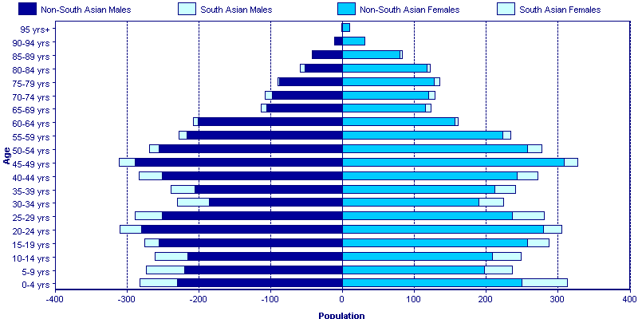
Practice Deprivation Profile (National Quintiles of Deprivation based on August 2009 capitation)

Health Implications of Practice Deprivation Profile - The largest proportion of patients registered with Ashcroft Surgery fall within quintile 1, the most deprived quintile. A substantial proportion of registered patients also fall within quintile 3, the third most deprived quintile.

Health Inequalities in Bradford

The following section provides information about the health of people within the different national quintiles of deprivation. The numbers in each table refer to the population of Bradford as a whole; the shaded area of each table highlights the quintiles where the higher proportions of patients for this practice reside.
Mortality in the Population of Bradford: All Causes, Under 75 Years of Age (2002-2009)

Data from Bradford District as a whole suggests that the premature (under 75 years of age) directly age
standardised mortality rate (ASR) for all causes has fallen during the last decade, especially for the two most deprived quintiles. From the table above, it can be seen that although the overall rate is falling it is falling less noticeably in the least deprived quintile. The gap between the most and least deprived quintiles appears to be narrowing.

Cancer and Circulatory Disease, Under 75 Years of Age, All Bradford (2007-2009)

The rates of under 75 Circulatory disease mortality represent a continued reduction in all of the deprivation quintiles. When compared with the data from 2003-2005 (not shown here), it appears that the gap in rates between the most and least deprived quintiles is narrowing. Cancer mortality rates show similar trends.

Life Expectancy, All Bradford (2007-2009)

Based on data from 2007 to 2009, life expectancy in the most deprived quintile is 72.0 years for males. This is a small increase from 71.0 years in 2006 to 2008 and shows that the inequalities gap in life expectancy is narrowing for males. Life expectancy for females, for similar time periods, has increased in the most and least deprived quintiles.

Births and Infant Mortality, All Bradford (2007-2009)

The infant mortality rate has decreased slightly since 2006-2008. The decrease occurred in the two least deprived quintiles. The gap in inequality between the most and least deprived quintiles has decreased since 2006-2008.

Since 2006-2008 rates of stillbirth have remained the same across the quintiles, except for a small increase in the most deprived quintile. This has resulted in an increase in the gap in inequality between the most and least deprived quintiles since 2006-2008.

The overall proportion of babies born with a low birth weight has remained unchanged since 2006-2008.

Practice Level Indicators

Results of the Patient Experience Survey

Screening

Practice Level Indicators

Immunisations

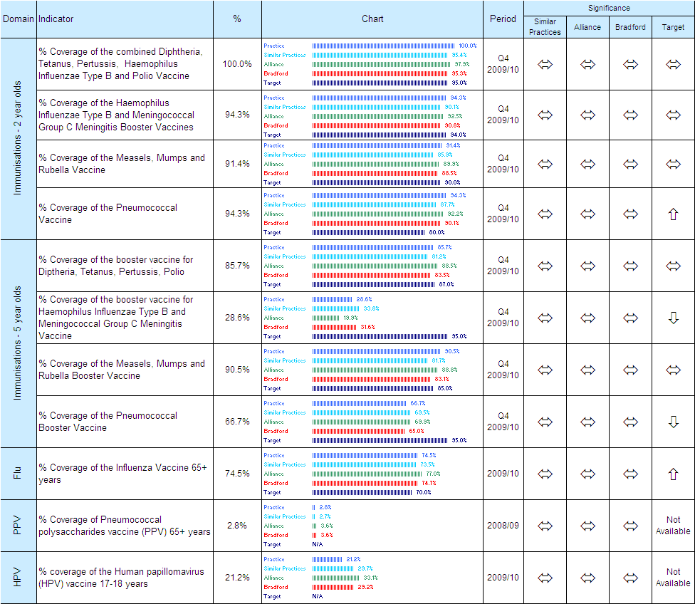

Summary of the Tobacco Control Health Equity Audit

Smoking is the single biggest preventable cause of illness and premature death in the UK, causing a range of diseases. An estimated 80,000 people in the UK die each year because of smoking.  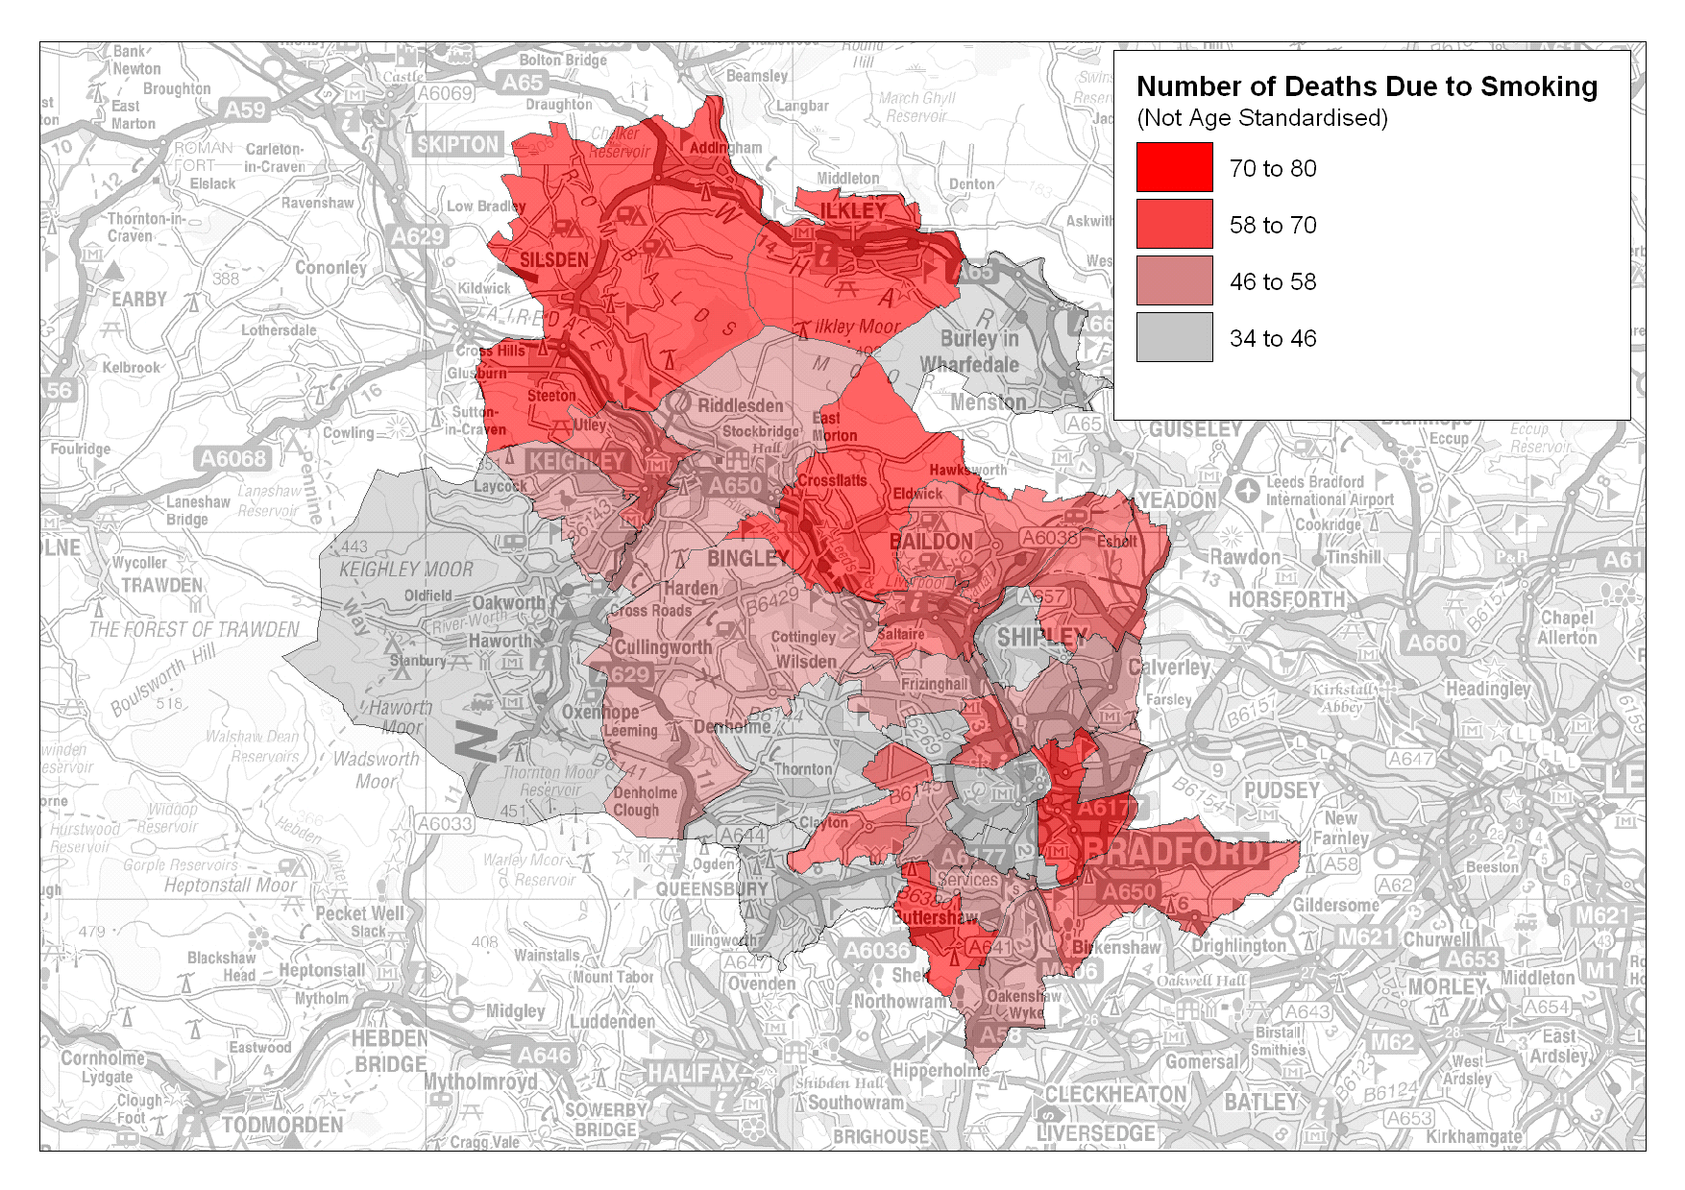  There are approximately 8,100 admissions attributable to smoking per year and 820 deaths in Bradford District  Data recorded by GPs estimates smoking prevalence to be 19% in adults but some patients do not have their smoking status recorded so this may be an underestimate.  Bradford’s own Stop Smoking Service has historically performed very strongly against the increasingly challenging 4 week quit targets monitored by the Department of Health. Quit rates fall well within the expected range of 35-70%.  Success with pregnant smokers has been more challenging. In response to this, Bradford’s Local Stop Smoking Services have redesigned the pathway for pregnant smokers and local (unvalidated) data indicates an improved quit rate of 24.4% Q1-Q3 2009/10. | Gender: Between April 2008 and November 2009 a total of 11,406 patients were referred to the Stop Smoking Service and set a quit date. A further 962 patients received a referral but set no quit date. 54% of those setting a quit date were female, 46% male.  0  5  10  15  20  25  30  35  40  45  50  Female  Male  %  Lost to Followup  Not Quit  Quit  Ethnicity: 88.6% of the patients accessing the service and setting a quit date were white, whilst around 9% were Asian.  Occupation: Around 18.5% of patients are classed as working in routine and manual jobs. Recording of occupation data is increasing due to the ‘phasing in’ of the new smoking cessation database.  Quit Rates: Between April 2008 and November 2009 45.5% of patients who had set a quit date had quit at 4 weeks. Majority quitters are from an intermediate economic status, those in managerial and professional work, and those patients who are retired. Lower than average quit rates were observed in full time students, home carers, the unemployed and long term sick.  In general, quit rates increase with age range, but the number of patients also falls. This may reflect a more determined pattern of quitting amongst older people, who may be motivated by co morbidities and advancing age to quit.  Little Horton, Manningham, Keighley Central, Keighley West and Bowling and Barkerend wards are areas of  concern as the exhibit high smoking | prevalence but low service uptake and low quit rates.  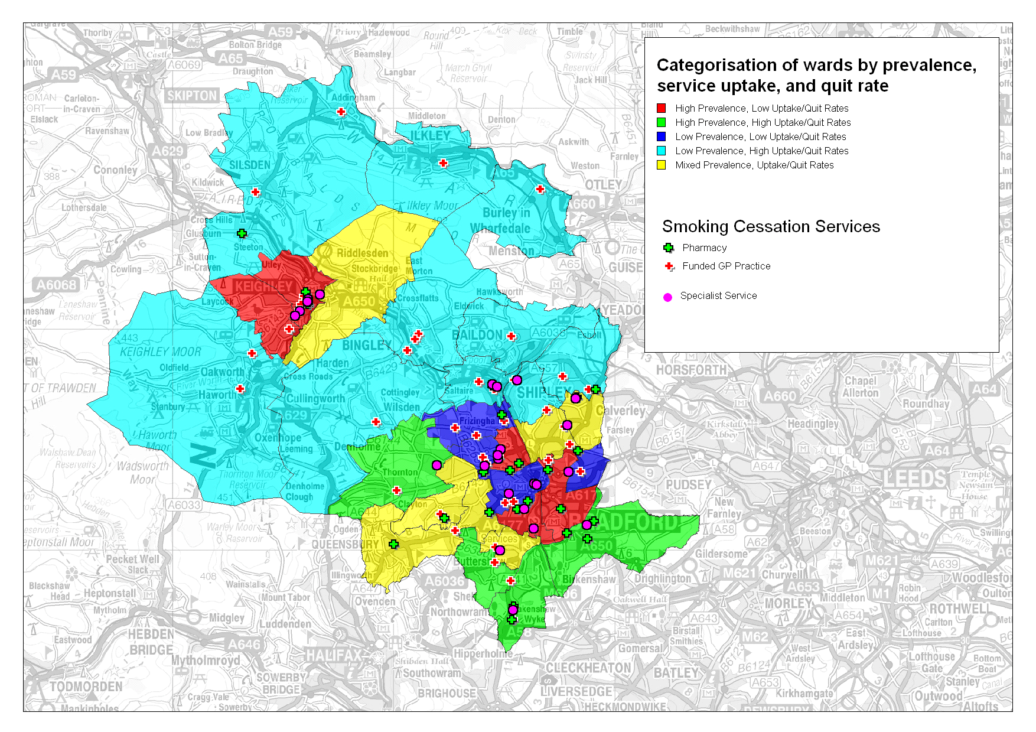  Tong, Wyke, Royds and Thornton wards were areas of high smoking prevalence but also high service uptake and quit rates.  Maternity data: In Bradford district  during 2008/9 approximately 16% women reported that they were smoking at booking-in with the midwife. 14.3 % reporting that they were smoking at the time of delivery.  28% of White women reported they smoked at booking-in compared to only 1.9% of Asian women.  The most disadvantaged mothers are more likely to smoke and less likely to quit.  In Tong, Wyke, Eccleshill and Keighley West wards smoking during pregnancy is more than double the national average.  Caveats: There is currently no reliable way of ascertaining smoking prevalence. The figures here are based on the Bradford and Airedale Health and Lifestyle Survey 2007/08 self reported smoking status, with numbers of smokers calculated from applying prevalence to GP registered populations. There is likely to be an under reporting of smoking status.  No local estimates of smoking prevalence amongst routine and manual workers exist and the data here is based on national estimates. These are likely to be conservative given Bradford’s deprivation profile.

A focus on Obesity in Bradford District (By Public Health Team)
Obesity is a major public health concern, both in terms of the impact on patients and from the perspective of the NHS and other institutions. Recent local Public Health research has indicated that 106,608 people are obese within Bradford. This focus page outlines the key statements from the work carried out by the Public Health team.
As part of the research data was extracted from the general practices in order to estimate the numbers of obese adults and determine the prevalence of obesity within the Bradford district. The data extract showed whether a body mass index (BMI) measurement had been taken within the past 20 months (31.1.08 - 30.09.09). The data showed that 34% of the patients within the sample had a recorded BMI.

About the Sample Data
- Obesity is defined as those people having a BMI > 30.
- In total, 84% of the Bradford GP registered population are represented in the data.
- The data was taken from 70 of the 82 practices across the four Alliances.
- 29% of registered patients had a BMI measured between 31.1.08 - 30.09.09, although there is considerable variability in reporting across age bands (Figure 1).
- Overall reporting levels are higher in BANCA and CityCare compared to other alliances, particularly for middle age and older adults.
Figure 1: BMI Reporting as % of registered patients by Alliance and Age group.

Obesity by Age & Sex
- Over a third of Bradford’s adult population are overweight (BMI 25-30 = 146,475 adults) and just over one quarter are obese (BMI > 30 = 106,608 adults).
- For both sexes there is a trend of increasing obesity prevalence with age (until 60 years), with a higher prevalence of morbid obesity amongst women, Figure 2.
- 57.5% of women and 64.6% of men aged 16 and over are overweight or obese.

Figure 2: Obesity Prevalence by age and sex for Bradford District
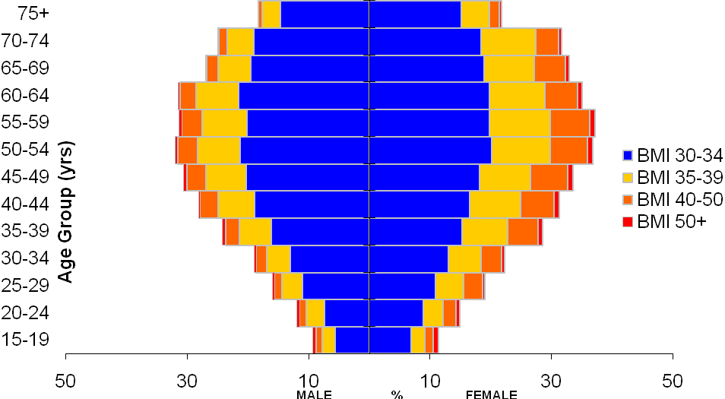

Obesity at Alliance Level
- The S&W Alliance has the highest overall estimated prevalence of obesity at 28.7% and the highest prevalence for each BMI category within the obese range (Figure 3).
- An estimated 4.4% of the CityCare population are underweight (BMI<18.5). This is higher than other Alliances and the overall estimate for Bradford of 3.2%.
- Of the four Alliances, Airedale has the lowest prevalence of obesity and highest proportion of adults classified as ‘normal weight’ (estimated as 38.1%).
Figure 3: Estimated Prevalence of patients in each BMI category by Alliance

Key Points for Bradford

Some of the national figures contained within this document and in the table above are the copyrighted material of organisations other than Bradford and Airedale tPCT. Such material must not be distributed more widely without express permission. For further information about these figures and the use of them, please see the Practice Profiles: User Guide for further details.

